Key Learning Objectives
- Six Basic Sentence Patterns
- Adverbials
- Basic Diagramming

Test Sections
Multiple Choice: 30 points
- 15 questions at 2 points each
- 20 minutes

Sentence Labeling 30 points
- 5 questions at 6 points each
- 20 minutes

Sentence Diagrams: 40 points
- 5 diagrams at 8 points each
- 20 minutes

Sentence Creation Bonus: 12 points
- 4 questions at 3 points each
- 10 minutes

Section A: Multiple Choice
Question One: Which of the following sentence patterns best describes the sentence below? (2 pts)
Answer:_____
Sentence: Curiously, the white rabbit was always late.
- Linking Verb with a Subject Complement (Noun Phrase)
- Copular Be with a Subject Complement (Adjective Phrase)
- Ditransitive Verb with a Direct Object and an Object Complement (Noun Phrase)
- Intransitive Verb

Question Two: Which of the following sentence patterns best describes the sentence below? (2 pts)
Answer:_____
Sentence: In winter, my aunt brings every relative a new wool hat.
- Linking Verb with a Subject Complement (Noun Phrase)
- Ditransitive Verb with a Direct Object and an Indirect Object
- Ditransitive Verb with a Direct Object and an Object Complement (Noun Phrase)
- Intransitive Verb

Question Three: Which of the following sentence patterns best describes the sentence below? (2 pts)
Answer:_____
Sentence: My youngest sister appears so passive.
- Ditransitive Verb with a Direct Object and Object Complement (Noun Phrase)
- Copular Be with a Subject Complement (Noun Phrase)
- Linking Verb with a Subject Complement (Adjective Phrase)
- Transitive Verb with a Direct Object and Indirect Object

Question Four: Which of the answers below is serving as an Optional Adverbial in this sentence? (2 pts)
Answer:_____________
Sentence: Typically, my neighbor brings me Christmas treats.
- “my neighbor”
- “me”
- “Typically”
- ‘Christmas treats”

Question Five: Which of the answers below is serving as a Subject Complement in this sentence? (2 pts)
Answer:_____________
Sentence: All my efforts were a waste of time after all.
- “All my efforts”
- “were”
- “a waste of time”
- “after all”

Question Six: Which of the answers below is serving as an Indirect Object in this sentence? (2 pts)
Answer:_____________
Sentence: The little goblin threw me a potion.
- “The little goblin”
- “threw”
- “me”
- “a potion”

Question Seven: What type of phrase listed below best describes the Object Complement in this sentence? (2 pts)
Answer:_____________
Sentence: All my friends called me ridiculous for my Halloween costume.
- Noun Phrase
- Adjective Phrase
- Prepositional Phrase
- Adverb Phrase

Question Eight: What type of phrase below best describes the Subject Complement in this sentence? (2 pts)
Answer:_____________
Sentence: Some professors are also digital influencers
- Adverb Phrase
- Prepositional Phrase
- Adjective Phrase
- Noun Phrase

Part B: Sentence Labeling – 6 pts each
In the sentence below, I have identified the parts of speech. In the two rows above, I would like you to identify the phrase type and the role of the phrase. You are welcome to write out your full answers or use the abbreviations below.
Phrase Types
- Noun Phrase = NP
- Verb Phrase = VP
- Adjective Phrase = ADJP
- Adverb Phrase = ADVP
- Prepositional Phrase = PP
Roles
- Subject = Subj
- Predicate = Pred
- Adverbial = Advl (be sure to include the “l” to distinguish Adveribals from Adverb Phrases
- Subject Complement = SC
- Direct Object = DO
- Indirect Object = IO
- Object Complement = OC

Example: My dad called me quite foolish after my wreck.
ROLE | Subject |  | Predicate | Direct Object | Object Complement |  | Adverbial
PHRASE | NP |  | VP | NP | ADJP |  | PP
 | My | dad | called | me | quite | foolish | after | my | wreck
 | Det | N | V | Pro | Adv | Adj | Prep | Det | N

Question Nine: Identify the Phrase Type and Role for each empty blank (6 pts)
Sentence: Under pressure, she feels very confident in her skills.
ROLE | Adverbial |  | Subject | Predicate | Subject Complement
PHRASE | PP |  | NP | MVP | ADJP
WORD | Under | pressure | she | feels | very | confident | in | her | skills
Part of Speech | Prep | NP | Pro | V | Adv | Adj | Prep | Det | N

Question Ten: Identify the Phrase Type and Role for each empty blank (6 pts)
Sentence: My friend called her boss a real jerk.
ROLE | Subject |  | Predicate | Direct Object |  | Object Complement
PHRASE | NP |  | MVP | NP |  | NP
WORD | My | friend | called | her | boss | a | real | jerk
Part of Speech | Det | N | V | Det | N | Det | Adj | N

Question Eleven: Identify the Phrase Type and Role for each empty blank (6 pts)
Sentence: Obviously, I sent Larry the money!
ROLE | Adverbial | Subject | Predicate | Indirect Object | Direct Object
PHRASE | ADVP | NP | MVP | NP | NP
WORD | Obviously | I | sent | Larry | the | money
Part of Speech | Adv | Pro | V | N | Det | N

Sentence Diagrams: 30 points (5 diagrams, 8 points each)
On the following pages, you will find five sentences. Each sentence is worth eight points.
- Correctly label the sentence pattern
  - Copular Be
  - Linking Verb
  - Intransitive
  - Transitive
  - Ditransitive with Direct Object and Indirect Object
  - Ditransitive with Direct Objecte and Object Complement

- Complete a diagram in the style we have been practicing.

Please draw the diagrams by hand or using the digital tool on our Canvas page. I will grade generously, and I am not extremely concerned about the specific codes you use, so long as you label things clearly and accurately. I am concerned that you draw the lines pointing to the right places..

- Please be sure to include a “node/phrase level” for each phrase (NP, VP, ADJP, ADVP, PP).

- You do not need to label the “role” of the phrases (Direct Object, Subject Complement, etc), but you may do it if you find it helpful.

I have provided five empty pages in the back of the exam if you need them for corrections or practice. Please just clearly indicate which is your final answer!

Question Twelve: Please label the sentence pattern and diagram this sentence (8 pts)
Sentence: On the bus, every cool kid looks so scary.
A: Sentence Pattern: Linking Verb
B: Diagram the Sentence
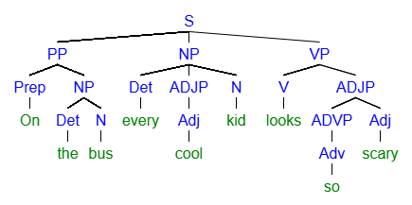
Question Thirteen: Please label the sentence pattern and diagram this sentence (8 pts)
Sentence: I often eat at fancy restaurants with my wife.
A: Sentence Pattern: Intransitive
B: Diagram the Sentence
Both of these are fine

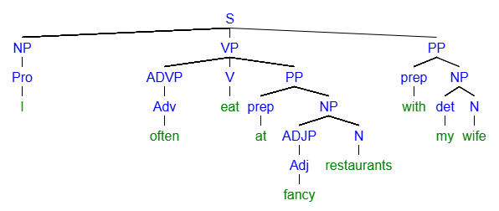
Question Fourteen: Please label the sentence pattern and diagram this sentence (8 pts)
Sentence: Honestly, my students give me inspiration for all the hard work
A: Sentence Pattern: Ditransitive with Direct Object and Indirect Object
B: Diagram the Sentence
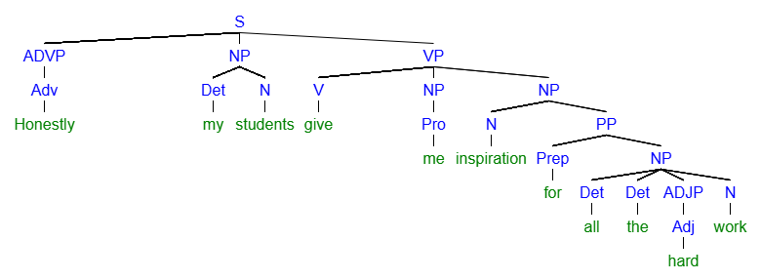
Question Fifteen: Please label the sentence pattern and diagram this sentence (8 pts)
Sentence: Some schools award impressive writers a big scholarship.
Det N V Adj N Det Adj N
A: Sentence Pattern:
B: Diagram the Sentence
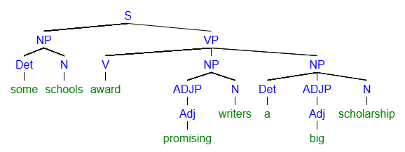

Section D: Sentence Creation - Bonus
For section D and the Bonus, please write all the new sentences about a movie, book, or TV show you like. Feel free to reuse the same ideas and characters from the movie, book, or TV show as many times as you like.
I will ask you to please chose a DIFFERENT movie, book, or TV show for the actual essay.
Name the movie, book, or TV show here:________________________________________________________________________

Question Sixteen: (3 pts bonus)
Write a sentence containing a Noun Phrase Serving as Subject Complement

Question Seventeen: (3 pts bonus)
Write a sentence containing a Prepositional Phrase serving as an Adverbial.

Question Eighteen: (3 pts bonus)
Write a sentence containing a Pronoun serving as a Direct Object

